ASSIGNMENT TITLE:
CA LAB
SUBMITTED BY:
ABEERA ASHFAQ
SUBMITTED TO:
PROFF MEHMOOD

SUMMARY OF LAB NO 5
Introduction to Proteus
The primary objective of this lab was to learn how to use the Proteus software environment for schematic capture and circuit simulation.
- Setting Up the Project:
  - Open Proteus and start a new design from the File menu.
  - Select the "Default" template from the "Create New Design" dialog.
- Selecting Components:
  - Open the Library Browser by clicking the 'P' button or selecting "Pick Device/Symbol" from the Library menu.
  - Search for specific keywords ("LED", "Resistors") and double-click to add them to the Object Selector.
- Building the Circuit:
  - Select a component from the Object Selector list and click on the Editing Window to place it.
  - Right-click in the Editing Window to place Ground (0V) or Power (5V) terminals.
  - Connect the components using the wiring tool to complete the schematic.
- Simulation Tasks:
  - Task 1: Create a circuit with a 5V source and two resistors (5.1k and 3.3k) to measure the voltage across each and the total current.
  - Task 2: Create a parallel circuit with a 9V source and three resistors (10k, 2k, and 1k) to measure individual currents and node voltages.

PROTEUS SCREENSHOTS
TASK 2
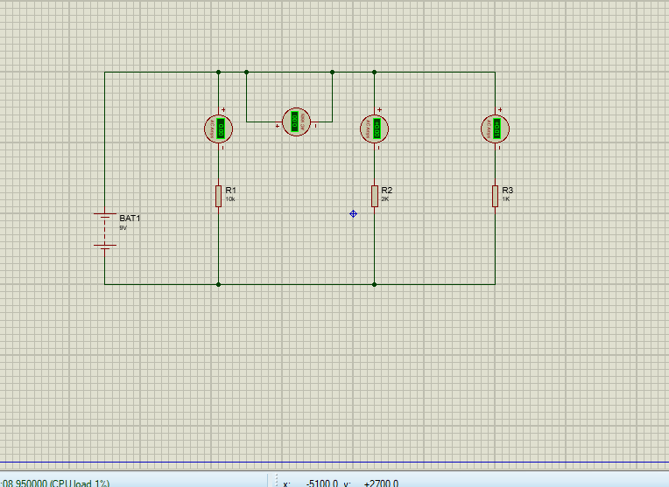

TASK 1
